EduBridge Learning Pvt.Ltd

Center: Salem-Algapuram

A Mini Project Report

On

**Simple Banking Application**

**PRESENTED BY**

Batch Code: 2022-7397

**Name: Sandeep Maurya EN: EBEON0422592382**

**Guidance by**

**Trainer: Chittaranjan Ghosh**

**(**EduBridge Learning Pvt.Ltd**)**

**Index**

|  |  |  |
| --- | --- | --- |
| **Sr. no.** | **Contains** | **Page no.** |
| 01 | Introduction………………………………………………… | 3 |
| 02 | System Requirements………………………………………  Software Requirements.…………………………..  Hardware Requirements.…………………………. | 4 |
| 03 | Source Code………………………………………………... | 5 |
| 04 | Outputs……………………………………………………… | 9 |
| 05 | Conclusion…………………………………………………… | 12 |

**Introduction**

We will learn how to create a mini-application for a banking system in Java. In this program, we will add some basic functionalities of a bank account like a deposit of amount, withdrawal of amount, etc. Initially, the program accepts the number of customers we need to add and adds the customer and account details accordingly. Further, it displays the series of menus to operate over the accounts.

**System Requirements**

**Software Requirements:**

**Name of the component Specification**

Operating Windows

Code Editor Eclipse IDE

Languages JAVA

**Hardware Requirements:**

**Name of the component Specification**

Processor Intel Core i5

Ram 8 GB

Hard Disk 1 TB

System Type 64-bit Operating System

**Source Code**

**package** Account;

**import** java.util.Scanner;

**class** BankDetails {

**private** String accno;

**private** String name;

**private** String add;

**private** String acc_type;

**private** **long** balance;

Scanner sc = **new** Scanner(System.***in***);

//method to open new account

**public** **void** openAccount() {

System.***out***.println("----------------------------------------------------------------------------------------------------------------------");

System.***out***.print("Enter Account No: ");

accno = sc.next();

System.***out***.print("Enter Account type: ");

acc_type = sc.next();

System.***out***.print("Enter Name: ");

name = sc.next();

System.***out***.print("Enter Address: ");

add = sc.next();

System.***out***.print("Enter Balance: ");

balance = sc.nextLong();

}

//method to display account details

**public** **void** showAccount() {

System.***out***.println("Name of account holder: " + name);

System.***out***.println("Address of account holder: " + add);

System.***out***.println("Account no.: " + accno);

System.***out***.println("Account type: " + acc_type);

System.***out***.println("Balance: " + balance);

}

//method to deposit money

**public** **void** deposit() {

**long** amt;

System.***out***.println("Enter the amount you want to deposit: ");

amt = sc.nextLong();

balance = balance + amt;

}

//method to withdraw money

**public** **void** withdrawal() {

**long** amt;

System.***out***.println("Enter the amount you want to withdraw: ");

amt = sc.nextLong();

**if** (balance >= amt) {

balance = balance - amt;

System.***out***.println("Balance after withdrawal: " + balance);

} **else** {

System.***out***.println("Your balance is less than " + amt + "\tTransaction failed...!!" );

}

}

//method to search an account number

**public** **boolean** search(String ac_no) {

**if** (accno.equals(ac_no)) {

showAccount();

**return** (**true**);

}

**return** (**false**);

}

}

**public** **class** BankingApp {

**public** **static** **void** main(String arg[]) {

Scanner sc = **new** Scanner(System.***in***);

//create initial accounts

System.***out***.print("How many number of customers do you want to Create? ");

**int** n = sc.nextInt();

BankDetails C[] = **new** BankDetails[n];

**for** (**int** i = 0; i < C.length; i++)

{

C[i] = **new** BankDetails();

C[i].openAccount();

}

// loop runs until number 5 is not pressed to exit

**int** ch;

**do** {

System.***out***.println("\n-------------------------------------------------------------------------------------------------------------------");

System.***out***.println("\n ***Banking System Application** ");

System.***out***.println("\n-------------------------------------------------------------------------------------------------------------------");

System.***out***.println("\n 1. Display all account details \n 2. Balance Checking with A/c \n 3. Deposit the amount \n 4. Withdraw the amount \n 5. Exit ");

System.***out***.println("----------------------------------------------------------------------------------------------------------------------");

System.***out***.println("Enter your choice: ");

ch = sc.nextInt();

**switch** (ch) {

**case** 1:

**for** (**int** i = 0; i < C.length; i++) {

C[i].showAccount();

}

**break**;

**case** 2:

System.***out***.print("Enter account no!..you want to check...... ");

String ac_no = sc.next();

**boolean** found = **false**;

**for** (**int** i = 0; i < C.length; i++) {

found = C[i].search(ac_no);

**if** (found) {

**break**;

}

}

**if** (!found) {

System.***out***.println("\n-------------------------------------------------------------------------------------------------------------------");

System.***out***.println("Search failed! Account doesn't exist..!!");

}

**break**;

**case** 3:

System.***out***.print("Enter Account no. : ");

ac_no = sc.next();

found = **false**;

**for** (**int** i = 0; i < C.length; i++) {

found = C[i].search(ac_no);

**if** (found) {

C[i].deposit();

**break**;

}

}

**if** (!found) {

System.***out***.println("\n-------------------------------------------------------------------------------------------------------------------");

System.***out***.println("Search failed! Account doesn't exist..!!");

}

**break**;

**case** 4:

System.***out***.print("Enter Account No : ");

ac_no = sc.next();

found = **false**;

**for** (**int** i = 0; i < C.length; i++) {

found = C[i].search(ac_no);

**if** (found) {

C[i].withdrawal();

**break**;

}

}

**if** (!found) {

System.***out***.println("\n-------------------------------------------------------------------------------------------------------------------");

System.***out***.println("Search failed! Account doesn't exist..!!");

}

**break**;

**case** 5:

System.***out***.println("Thank You for using BankingApp!......");

System.***out***.println("See you soon...........");

**break**;

}

}

**while** (ch != 5);

}

}

**Output**

Screenshot:

Steps 1.

1st We are Run this code by eclipse. And We Enter How many numbers of customers do you want to Create. Entered—> 2

Steps 2.

Now Shows Banking System Applications- there are 5 menu Option:

Steps 3.

Here we are Enter 2, For checking Balance:

Steps 4.

Next option 3 choose: for Deposit amount:

Steps 5.

Next option 4 choose: for Withdraw amount:

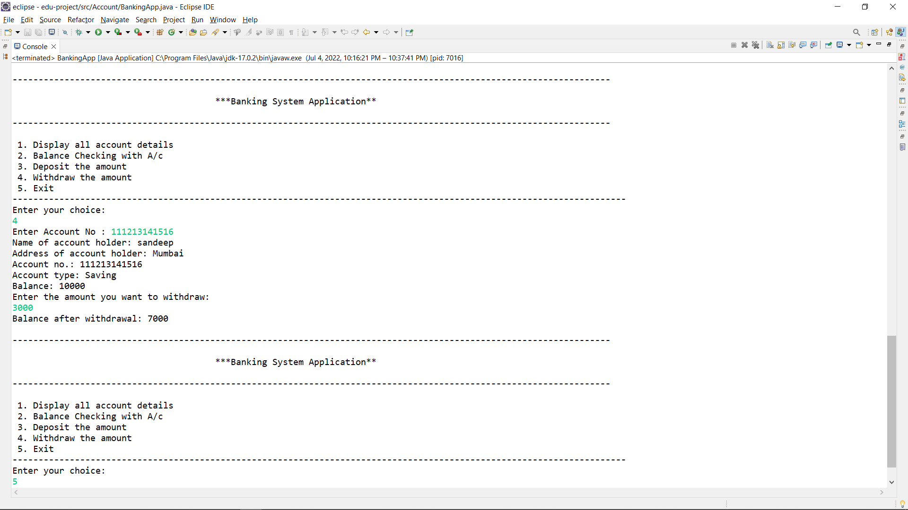

Steps 6.

Next option 5 choose: Exit

**Conclusion**

Here we study about simple banking system in **java** application, We are preform some basic operation like Balance Enquiry, Amount deposit, Amount withdraw and exit from Account.